**AIM : . Design a system for doors at home, such that whenever a door is opened, a light turns on for 1000 ms if it is day & 2000 ms if it is night.**

**APPRATUS :** 1 LED, breadboard, wires, Arduino , resistor ,LDR.

**CIRCUIT DIAGRAM** **:**

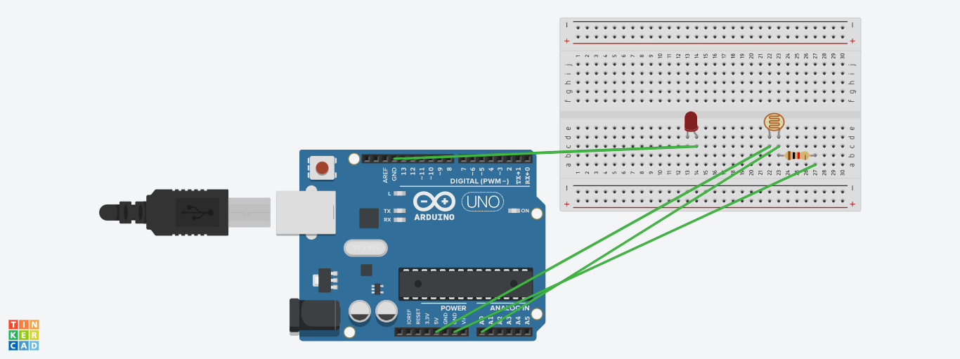

**THEORY** :

The LED has one p junction and n junction inside it, p is longer while n is shorter.

Breadboard have network of connection inside it. Ultrasonic sensor is used to measure distance. LDR or photodiode is used to detect light. Whenever a door is opened, a light turns on for 1000 ms if it is day & 2000 ms if it is night.

**LERNING & OBSERVATION :**

1. Learned how to connect the connection inside the breadboard.
2. Connection of LED in the breadboard and which is n side & p side of LED.
3. Learned how to upload code on arduino and work on it.
4. Learned how to use LDR or photodiode.

**PROBLEM & TROUBLESHOOTING:**

1. Connection of photodiode with arduino was a bit complicated.
2. Mistake in code uploading .

**PRECAUTIONS:**

1. Water should not be spilled up on the circuit.
2. LED should not be a damaged one.

**LEARNING OUTCOMES**:

1. Connecting photodiode with the Arduino.
2. Code building .